**ITS 530: Quiz 2 sample report**

**Visualization with ggplot2 library**

**See below cheat-sheet on this library for quick reference**

<https://rstudio.com/wp-content/uploads/2015/05/ggplot2-cheatsheet.pdf>

* **First I am reading my csv dataset**
* **Str(data) showed me general information about my dataset**

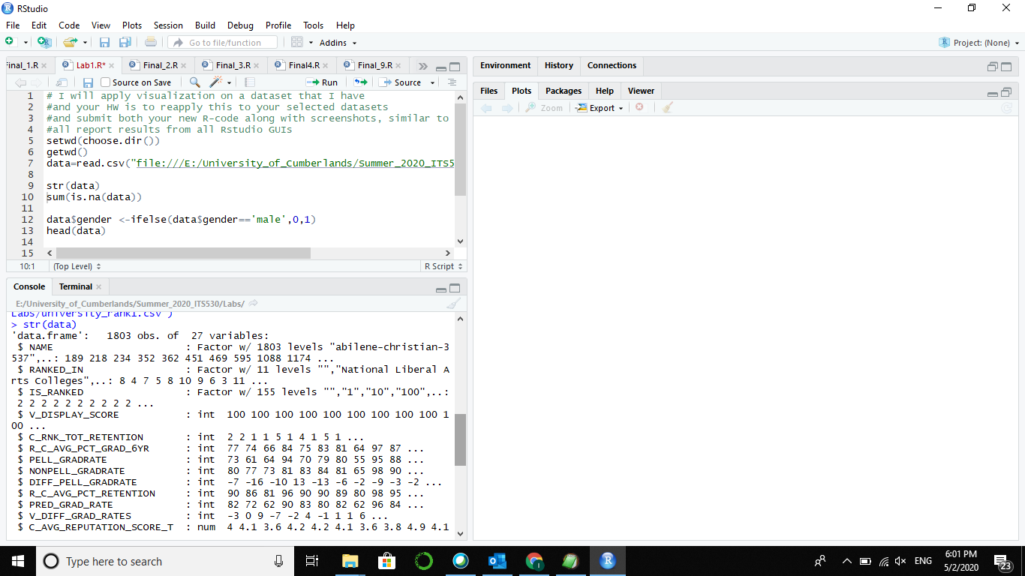

* My dataset has 1803 obs. of 27 variables:
* The second picture to show how many null values in my dataset



* I have many null variables
* Next I will start my ggplot2 visualization
* # This quiz we will look at ggplo2 library visualizations
* # Our examples are from the link <http://r-statistics.co/Top50-Ggplot2-Visualizations-MasterList-R-Code.html>
* Our first plot is called: Scatterplot. Screens below shows results of my code for two variables from my data. x=R_C_PCT_CLASSES_GT_50, y=IS_RANKED
* I basically want to study class size with University rank scale

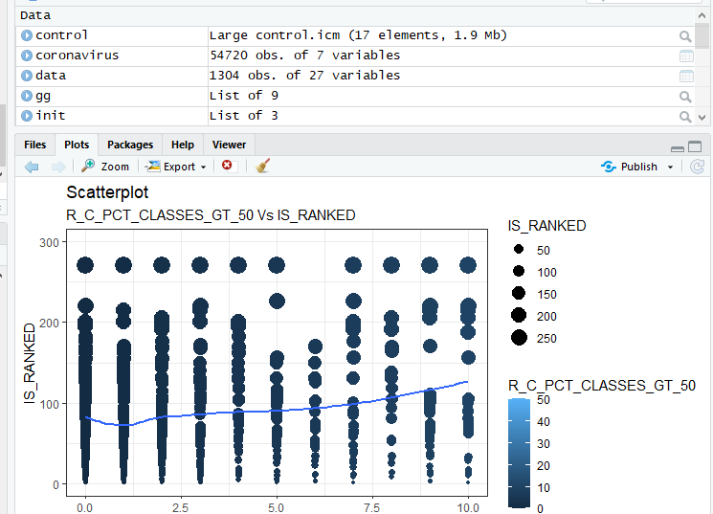

* The chart basically is telling me that Universities with lower rank tend to have less of those large classes
* The second chart scatter plot with encoding

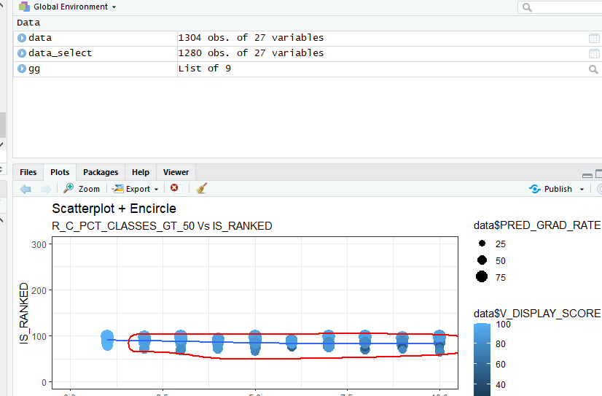

* Complete the above two charts based on your dataset and any 3 more charts from the <http://r-statistics.co/Top50-Ggplot2-Visualizations-MasterList-R-Code.html> (Important, the charts and your code should be based on your dataset). Submitting the code and figures from this link as is will not be accepted